ITEC 380: Managing IT Projects
Professor: Jose (Joe) Ascensio

OCT – 6 – 2025

Prabesh Rai | Angelina gochenour | Gladis munoz marin |
heidi schieber | sirona ramahi

MODULE 7 GROUP ASSIGNMENT
COMPLETE PROJECT MANAGEMENT PLAN

Project Name: University-Wide Print and Projection Upgrade Project
Project Sponsor: The University of Kansas
Prepared By: Team 1
Date: October 6 2025
- Introduction and Project Charter Summary
This is a complete Project Management Plan (PMP) document which defines how the university-wide print and projection upgrade project will be executed, monitored, controlled, and closed. It integrates all the required subsidiary plans such as scope, schedule, cost, stakeholder, risk, and HR into a cohesive strategy to ensure project success.
Project Goal: To replace all the outdated printers, scanners, multi-function devices, and projectors across the university to enhance efficiency and standardize technology.
Key Success Criteria:
  - Complete the entire upgrade project within the 60-day timeline.
  - Stay within the approved $393,000 cost baseline.
  - Meet the state contract standards that mandates the new updates.
2.0 Scope Management
This section defines the work required to ensure all planned work is performed without affecting the regular classes and routines effectively throughout various project phases.
2.1 Deliverables:
- Procurement of new hardware and software.
- System-wide configuration and network integration.
- Physical installation in all designated departments, buildings, and classrooms.
- End-user training and support documentation.
- Disposal of old equipment and updating asset record keeping.
2.2 Exclusions:
- Integration with non-standardized departmental software.
- Major network infrastructure upgrades.
2.3 Work Breakdown Structure (WBS):
The project is structured into three main levels of decomposition.
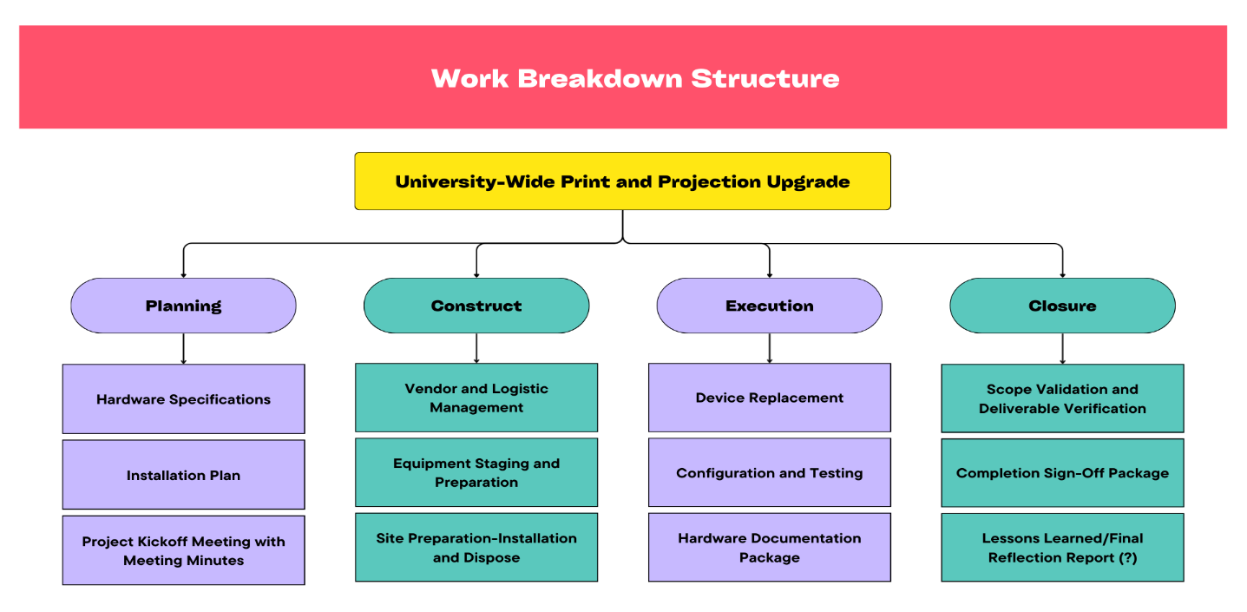

3.0 Schedule Management Plan
The project timeline is constrained by the critical 60-day deadline and the schedule will be measured using the Gantt chart. The Gantt chart is broken into four sequential steps as described in WBS. Each specific milestones listed below will be the key to track our project progress.
3.1 Key Milestones and Dependencies:
Milestone | Target Completion | Primary Dependency
Procurement Complete | End of Week 3 | Initial Funding and Vendor selection
Installation Phase | Week 4-6 | Vendor delivery timelines
Training and Testing | Week 7 | Physical installation complete
Project Closure | Week 8 | Training and testing sign-off

3.2 Schedule Control:
Project progress will be tracked weekly against the WBS and Gantt chart. Any deviation exceeding five days from the schedule baseline will trigger a mandatory project manager review and a formal schedule change request.
4.0 Cost Management Plan
The cost estimation is performed using a bottom-up approach in our project to aggregate costs from detailed task levels. The below table is the breakdown of cost category with its total budget approved.
Cost Category | Total Budget
Hardware Procurement | $205,000
Software and Setup | $35,000
Training and Support | $20,000
Disposal and Logistic | $30,000
Project Management | $92,500
Contingency Reserve | $40,500
Total Cost Baseline | $393,000

4.1 Cost Control:
Expenditures will be monitored weekly against the time-phased budget. If anticipated or realized expense exceeds the budget for specific work package by more than 10% requires and immediate escalation to the project manager.
5.0 Stakeholder Management Plan
This section defines the strategies and actions required to effectively identify, analyze, and engage stakeholders throughout the project lifecycle. Effective stakeholder management is critical to ensuring support, reducing resistance, and achieving project success within the defined schedule and budget.
5.1 Stakeholder Prioritization summary:
Stakeholder | Role | Influence | Impact | Primary Strategy
University | Chancellor | Executive Sponsor | High | High | Manage Closely | Keep Satisfied
Project Manager | Execution | High | High | Manage Closely
University IT Department | Technical Implementation | High | Medium | Manage Closely
Faculty & Staff | End users | Medium | High | Keep Informed and Consulted
Finance Office | Purchasing | Budgeting | High | Medium | Keep Informed
Vendor or Supplier | External resource | Medium | Medium | Manage Closely

5.2 Engagement Strategy:
The key engagement strategy for our project focuses on proactive communication tailored to each group’s interest level to ensure high influence stakeholders remain supportive and high impact stakeholders are engaged and prepared for any changes.
- Sponsor Level: Our strategy focuses on keeping their satisfaction high by ensuring the project remains on budget and schedule. Communication is mostly limited to high level dashboards and immediate alert of critical issues.
- Execution Level (PM, IT department, Vendors): We will use close and highly collaborative engagement for this level such as daily start up meetings, shared documentation using secure tools to ensure immediate issue resolution and coordination.
- End-user Level: We will use informational engagement strategy which focus on managing expectations and minimizing resistance through clear, timely announcements, and high-quality training sessions.
6.0 Communication Management Plan
This section defines the communication channels, formats, and responsibilities to ensure timely and effective information flow among stakeholders throughout the project.
Information | Recipient | Format | Channel | Frequency | Responsible
Executive status update | Chancellor, IT leadership | High-level email report | Weekly | Project manager
Team status & Issues | Project Team & IT department | Daily stand-up meeting, Zoom | Daily business days | Project manager
Budget & Procurement Status | Finance office, Project Manager | Detailed Spreadsheet email | Weekly | Finance department
End-user training schedules | Faculty & Staff | University email & announcement | Bi-weekly | Training lead
Change request status | All affected stakeholders | Email notification | As needed | Project manager

6.1 Communication Guidelines
Clarity: Messages will be concise, role-specific, and jargon-free where needed.
Timeliness: All updates tied to critical milestones will be sent within 48 hours of the event.
Feedback Loop: A communication channel (feedback form/email) will be open for stakeholders to ask questions or raise corcerns at any stage.
7.0 Human Resource Management Plan
We will use the roles and responsibilities defined by RACI chart and its summary to clearly map them with their key deliverables and ensure accountability across the team.
7.1 Roles and Responsibilities (RACI summary):
Key:
R – Responsible for completing the work
A – Accountable for ensuring task completion/sign off
C – Consulted before any decisions are made
I – Informed of when an action/decision has been made

 | Project Manager | Design Engineers | Implementation Manager | Training Leads | Functional Managers | Department Managers
Requirements Gathering | A | R | R | C | C | I
Coding Design | A | R | C |  | C | I
Coding Input | A | R
Software Testing | A | R | C |  | I | I
Network Preparation | A | C | R |  | I | I
Implementation | A | C | R | C | C | C
Conduct Training | A |  |  | R | C | C

7.2 Training and Development:
All team members, particularly the IT department staff involved in installation, will receive specialized training on the new hardware and configuration standards before the execution phase begins.
7.3 Performance and Rewards:
- Performance Review: Continuous feedback will be provided through weekly meetings and one-on-one sessions to evaluate performance against assigned task timelines. A formal review will be conducted before the resource release.
- Recognition: Planned rewards for successful completion include a celebration party, a CEO certificate of thanks, a company newsletter feature, and gift hampers during milestone completion.
8.0 Risk Management Plan
Throughout the project the risk management will be an ongoing, proactive process involving identification, qualitative analysis, and response planning.
8.1 Roles and Responsibilities:
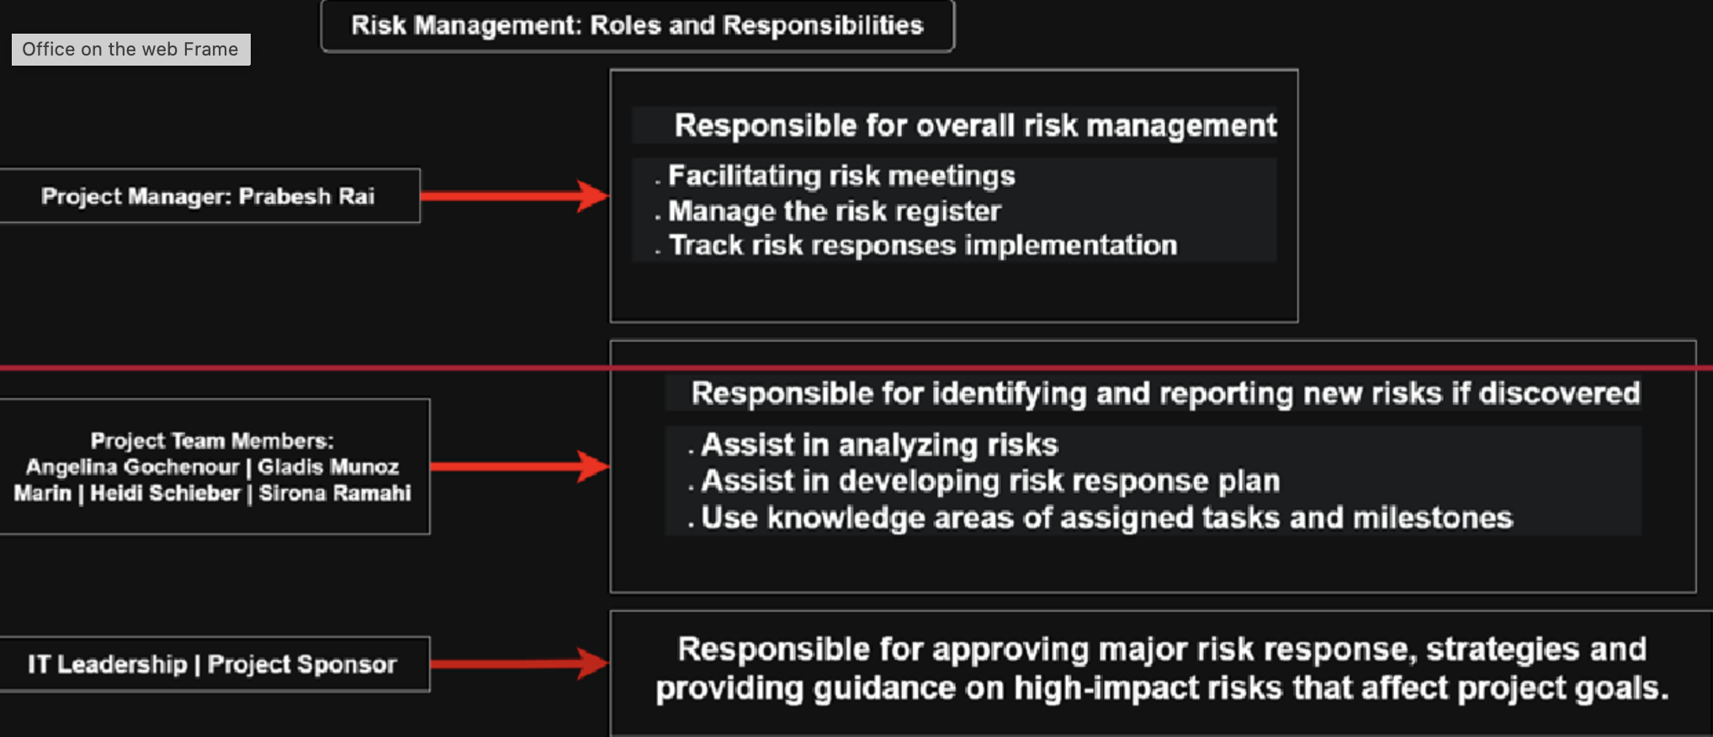
8.2 Risk Categories Breakdown
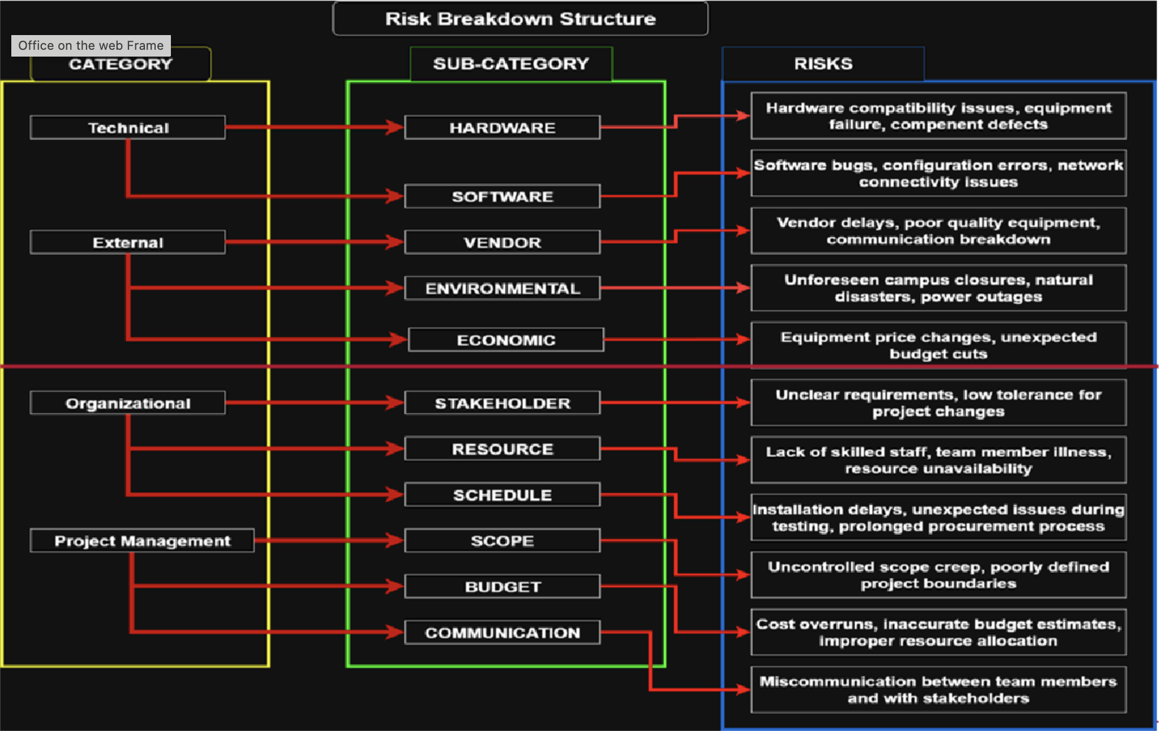

8.3 Key Risks and Response Strategies
Risk Description | Probability | Impact | Response Action
Hardware delivery delays | High | High | Order and stock equipment in advance; Negotiate vendor contracts with late delivery penalties
Incompatibility between new hardware and existing network or software | Medium | High | Select only pretested; standardized hardware models
Faculty resistance to changes | Medium | Medium | Mandatory; personalized training and dedicated post-implementation support hours

8.4 Contingency Planning:
A contingency reserve of $40,500 has been allocated to mitigate the financial impact of known risks. Fallback plans will be predefined for all high-impact risks.
9.0 Change Management Plan
Any request to change the scope, timeline, or budget must follow a formal, structured process to maintain project control.
- Request Submission: The stakeholder submits a written Change Request (CR) to the Project Manager.
- Review: The Project Manager assesses the request’s feasibility and preliminary impact on the schedule, budget, and resources.
- Team Analysis: The core project team evaluates the detailed impact of the proposed change.
- Decision: The IT leadership or Project Sponsor reviews the analysis and formerly decides to Accept, Deny, or Adjust the CR.
- Documentation: If approved, all relevant project documents (PMP, baseline, WBS, Risk Register) are updated, and all affected stakeholders are informed.

Time Log:
